CH 12 Enhancing Decision Making

學習目標:

* 1. 決策有哪些不同類型？決策過程如何進行？
  2. 資訊系統如何支持管理者的活動和管理決策？
  3. 商業智慧和商業分析如何支持決策？
  4. 組織中的不同決策者如何使用商業智慧？資訊系統在幫助團隊中的人們更有效地做出決策方面的作用是什麼？
* Roche: Changing Medical Care with Mobile Technology and Big Data

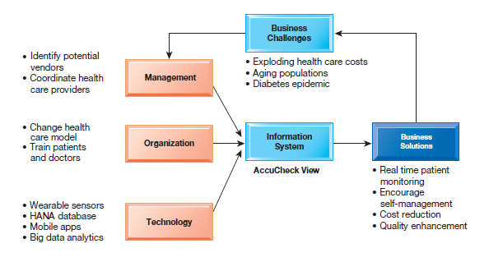

1. What are the different types of decisions, and how does the decision-making process work?
   * Business Value of Improved Decision Making

* Improving hundreds of thousands of “small” decisions adds up to large annual value for the business

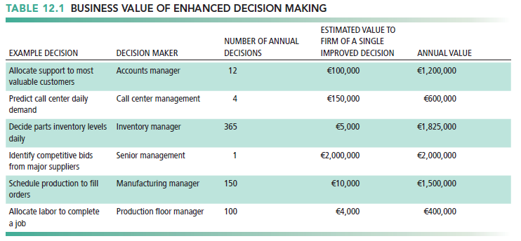

* + Types of Decisions
* Unstructured: Decision maker must provide judgment, evaluation, and insight to solve problem
* Structured: Repetitive and routine; involve definite procedure for handling so they do not have to be treated each time as new
* Semistructured: Only part of problem has clear-cut answer provided by accepted procedure
* In a firm
* Senior managers
  + - Make many unstructured decisions
    - For example: Should we enter a new market?
* Middle managers
  + - Make more structured decisions but these may include unstructured components
    - For example: Why is order fulfillment report showing decline in Minneapolis?
* Operational managers, rank and file employees
  + - Make more structured decisions
    - For example: Does customer meet criteria for credit?

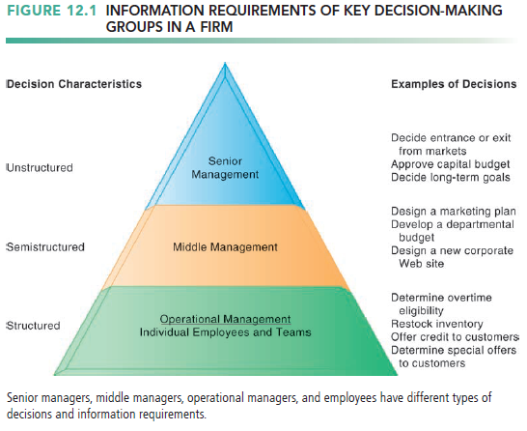

* + The Decision-Making Process
    - 1. Intelligence
* Discovering, identifying, and understanding the problems occurring in the organization
  + - 1. Design
* Identifying and exploring solutions to the problem
  + - 1. Choice
* Choosing among solution alternatives
  + - 1. Implementation
* Making chosen alternative work and continuing to monitor how well solution is working

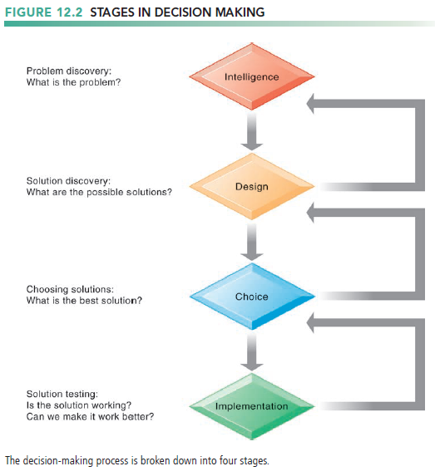

1. How do information systems support the activities of managers and management decision making?
   * Managerial Roles

* Preface
* Information systems can only assist in some of the roles played by managers
* Classical model of management: five functions
  + - Planning, organizing, coordinating, deciding, and controlling
* More contemporary behavioral models
  + - Actual behavior of managers appears to be less systematic, more informal, less reflective, more reactive, and less well organized than in classical model
* Observers find that managerial behavior actually has five attributes that differ greatly from the classical description.
  + - perform a great deal of work at an unrelenting pace
    - managerial activities are fragmented; most activities last for less than nine minutes, and only 10 percent of the activities exceed one hour in duration.
    - managers prefer current, specific, and ad hoc information
    - prefer oral forms of communication to written forms
    - managers give high priority to
    - maintaining a diverse and complex web of contacts that acts as an informal information system and helps them execute their personal agendas and short and long-term goals.
* Mintzberg’s 10 managerial roles

1. Interpersonal roles
   * + Figurehead
     + Leader
     + Liaison
2. Informational Roles
   * + Nerve center
     + Disseminator
     + Spokesperson
3. Decisional Roles
   * + Entrepreneur
     + Disturbance handler
     + Resource allocator
     + Negotiator

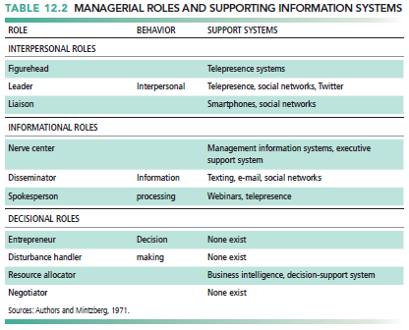

* + Real-World Decision Making
* Three main reasons why investments in information technology do not always produce positive results
* Information Quality
* High-quality decisions require high-quality information

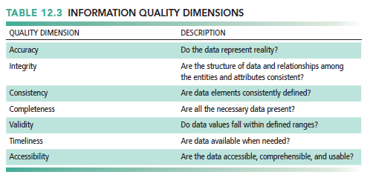

* Management Filters
* Managers have selective attention and have variety of biases that reject information that does not conform to prior conceptions
* Organizational Inertia and Politics
* Strong forces within organizations resist making decisions calling for major change
  + High-Velocity Automated Decision Making
* Made possible through computer algorithms precisely defining steps for a highly structured decision
* Humans taken out of decision
* Require safeguards to ensure proper operation and regulation

1. How do business intelligence and business analytics support decision making?
   * What is Business Intelligence?

* Business intelligence (BI)
* a term used by hardware and software vendors and information technology consultants to describe the infrastructure for warehousing, integrating, reporting, and analyzing data that come from the business environment, including big data.
* Infrastructure for collecting, storing, analyzing data produced by business
* Databases, data warehouses, data marts
* Business analytics
* Tools and techniques for analyzing data
* OLAP, statistics, models, data mining
* Business intelligence vendors
* Create business intelligence and analytics purchased by firms
* Oracle, SAP, IBM, Microsoft, and SAS.
  + The Business Intelligence Environment
* Data from the business environment
* Businesses must deal with both structured and unstructured data from many different sources, including big data. The data need to be integrated and organized so that they can be analyzed and used by human decision makers.
* Business intelligence infrastructure
* powerful database system that captures all the relevant data to operate the business. The data may be stored in transactional databases or combined and integrated into an enterprise-data warehouse or series of interrelated data marts.
* Business analytics toolset
* A set of software tools are used to analyze data and produce reports, respond to questions posed by managers, and track the progress of the business using key indicators of performance.
* Managerial users and methods
* Managers impose order on the analysis of data using a variety of managerial methods that define strategic business goals and specify how progress will be measured.
* include business performance management and balanced scorecard approaches focusing on key performance indicators and industry strategic analyses focusing on changes in the general business environment, with special attention to competitors.
* Delivery platform—MIS, DSS, ESS
* The results from business intelligence and analytics are delivered to managers and employees in a variety of ways, depending on what they need to know to perform their jobs.
* User interface
* analytics software suites feature data visualization tools, such as rich graphs, charts, dashboards, and maps.
* able to deliver reports on iPhones, iPads, and other mobile handhelds as well as on the firm’s web portal.

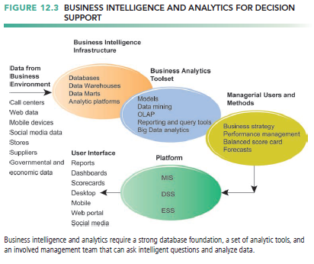

* + Business Intelligence and Analytics Capabilities
* Preface
* Business Intelligence and Analytics Capabilities
* Predictive Analytics
* Big Data Analytics
* Operational Intelligence and Analytics
* Location Analytics and Geographic Information Systems
* Management Strategies for Developing BI and BA Capabilities
* There are six analytic functionalities that BI systems deliver to achieve these ends
  + - Production reports: These are predefined reports based on industry specific requirements
    - Parameterized reports: Users enter several parameters as in a pivot table to filter data and isolate impacts of parameters.
    - Dashboards/scorecards: These are visual tools for presenting performance data defined by users.
    - Ad hoc query/search/report creation: These allow users to create their own reports based on queries and searches.
    - Drill down: This is the ability to move from a high-level summary to a more detailed view.
    - Forecasts, scenarios, models: These include the ability to perform linear forecasting and what-if scenario analysis and analyze data using standard statistical tools.

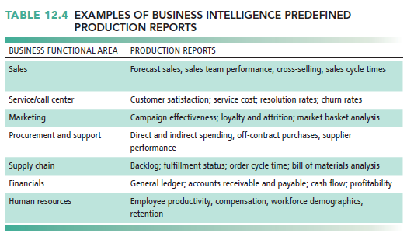

* Predictive Analytics
  + - the ability to model future events and behaviors
    - Use variety of data, techniques to predict future trends and behavior patterns
    - use statistical analysis, data mining techniques, historical data, and assumptions about future conditions to predict future trends and behavior patterns
    - Incorporated into numerous BI applications for sales, marketing, finance, fraud detection, health care
* Big Data Analytics
  + - Big data: Massive datasets collected from social media, online and in-store customer data, and so on
    - Help create real-time, personalized shopping experiences for major online retailers
    - Smart cities : Public records, Sensors, location data from smartphones, Ability to evaluate effect of one service change on system

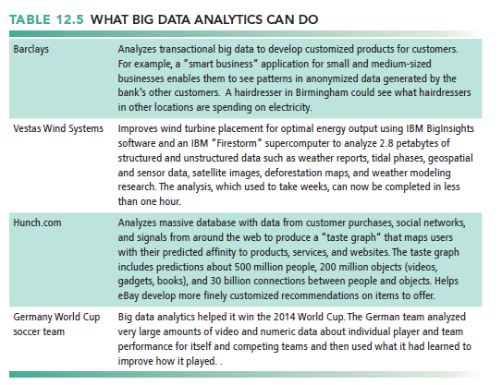

* Operational Intelligence and Analytics
  + - Operational intelligence: Business activity monitoring
    - Collection and use of data generated by sensors
    - Internet of Things : Creating huge streams of data from Web activities, sensors, and other monitoring devices
    - Software for operational intelligence and analytics enable companies to analyze their Big Data
* Location Analytics and Geographic Information Systems
  + - Ability to gain business insight from the location (geographic) component of data : Mobile phones Sensors, scanning devices, Map data
    - Geographic information systems (GIS) : Ties location-related data to maps
  + Management Strategies for Developing BI and BA Capabilities
* One-stop integrated solution
* Hardware firms sell software that run optimally on their hardware
* Makes firm dependent on single vendor—switching costs
* Multiple best-of-breed solution
* Greater flexibility and independence
* Potential difficulties in integration
* Must deal with multiple vendors

1. How do different decision-making constituencies in an organization use business intelligence, and what is the role of information systems in helping people working in a group make decisions more efficiently?
   * Preface

* Senior executives tend to use BI to monitor firm activities using visual interfaces like dashboards and scorecards.
* Middle managers and analysts are much more likely to be immersed in the data and software, entering queries and slicing and dicing the data along different dimensions.
* Operational employees will, along with customers and suppliers, be looking mostly at prepackaged reports.

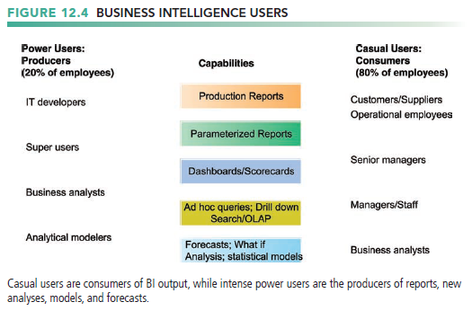

* + Decision Support for Operational And Middle Management
* Preface
* Operational and middle managers
* Use MIS (running data from TPS) for:
* Routine production reports
* Exception reports

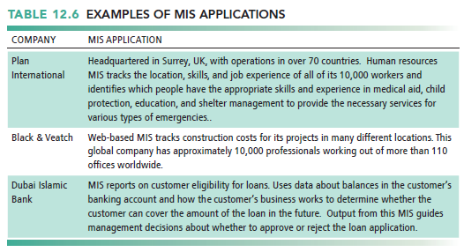

* Support for Semi-structured Decisions
* Super user” and business analysts
  + - Use DSS for:
    - More sophisticated analysis and custom reports
    - Semistructured decisions
    - Use mathematical or analytical models
    - Allow varied types of analysis
    - “What-if” analysis
    - Sensitivity analysis

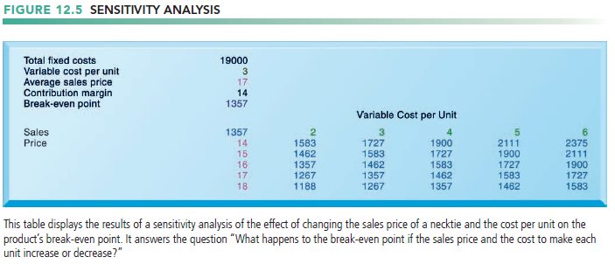

* + - Backward sensitivity analysis
    - Multidimensional analysis / OLAP
    - Spreadsheets have a similar feature for multidimensional analysis called a pivot table

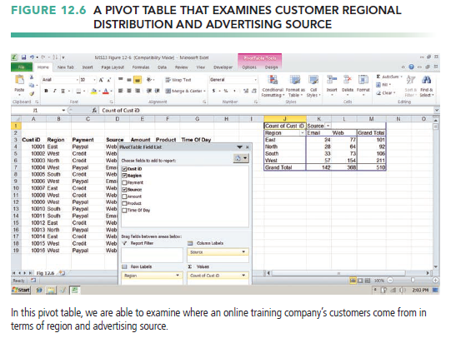

* + Decision Support for Senior Management: Balanced Scorecard and Enterprise Performance Management Methods
* ESS: decision support for senior management
* focus on the really important performance information that affects the overall profitability and success of the firm.
* Balanced scorecard method
  + - Financial
    - Business process
    - Customer
    - Learning and growth
* Key performance indicators (KPIs) measure each dimension
* Business performance management (BPM)
* Translates firm’s strategies (e.g., differentiation, low-cost producer, scope of operation) into operational targets
* KPIs developed to measure progress toward targets
* Data for ESS
* Internal data from enterprise applications
* External data such as financial market databases
* Drill-down capabilities

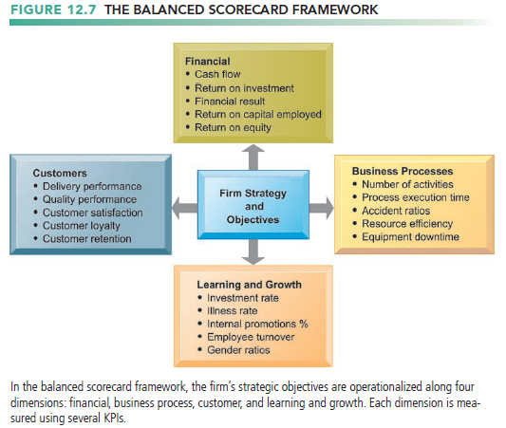

* + Group Decision-Support Systems (GDSS)
* Interactive system to facilitate solution of unstructured problems by group
* Specialized hardware and software; typically used in conference rooms
* Overhead projectors, display screens
* Software to collect, rank, edit participant ideas and responses
* May require facilitator and staff
* Enables increasing meeting size and increasing productivity
* Promotes collaborative atmosphere, anonymity
* Uses structured methods to organize and evaluate ideas